‘e-vidya” 2022-23

**Vigyan Kaushalya Vikas Program - STEM**

In the financial year 2022-23, the Sai’s Angel Foundation in partnership with TATA POWER initiated a pilot of STEM-(Science, Technology, Engineering and Math) program in the area of ‘e-vidya’. The e-vidya STEM project initiative aimed to deliver measurable qualitative improvements of students from classes 6 to 8 by generating interest in the subjects of Science, Maths and Gujarati. This was a distinctive learning project that aimed at providing wide-ranging inputs to the students through STEM activities, Maths and Gujarati .Teaching was done as per the groups divided by SAF. This journey was a unique learning experience which was also very challenging simultaneously encouraging. The students were very regular in attendance, enthusiastic, disciplined and had curiosity to learn. Sai’s Angel Foundation had successfully implemented pilot project that benefitted about 450 students in the identified villages of Mundra and Mandvi blocks of Kutch district.

* During the journey of 6 months from September, 2022 till February 2023, many different activities were carried out by developing foundational understanding in Mathematics/Gujarati and hands on activities for generating curiosity pertaining to Science.
* The project benefited about 450 students of 4 schools of Mandavi and Mundra blocks in Kutch district. COVID-19 had brought in many challenges especially in the field of education. ‘e-vidya’ STEM had tried to address these issues simultaneously providing additional STEM inputs that were mentioned in NEP 2020 and had provided access to quality education to the children.

This was an attempt to understand STEM model that would work for benefit of the school children in increasing their various hidden qualities and to develop their scientific temper.

**OBJECTIVES:**

* The key focus areas were enhancement of collaboration, critical thinking, creative thinking, communication and problem solving skills of the students.
* To improve understanding of the concepts introduced through tinkering activities like motion, force, and property of material including basic coding skills among students.
* Cultivating interest among students for subjects like science and math during regular schooling.
* Measuring improvement in performance of students through pre-test & post-test comparison

**IMPLEMENTATION OF ‘E-VIDYA’- STEM INITIATIVE**

The initiative was implemented in the zilla panchayat primary schools of Mandvi & Mundra blocks of Kutch district in Gujarat. Initially, 10 schools were jointly identified by Tata power and Sai’s Angel Foundation (SAF). The focused intervention was done in the schools of Mota Kandagara, Vandh, Tunda and Gudyali.

**INTERVENTION:**

Systematic execution of STEM model was done in 4 identified schools which included Training of Trainers of SAF teachers including 6 other school teachers, content development, kit distribution to students and Monitoring & Evaluation.

* There were about 400 students identified for the pilot and were divided into three categories like ‘A’, ‘B’ and ‘C’ and detailed tracking of the students was done . A ‘Training of Trainers’ was organized for imparting knowledge on the philosophy of the initiative and the implementation framework. TOT on STEM concepts for recruited SAF staff – offline and online & for Government teachers was conducted. First TOT was conducted on 09.09.2022 in which seven government teachers and 6 SAF teachers remained present. Monthly TOTs were carried out for SAF recruited staff on STEM and for teachers of ‘C’ group.
* Based on standardized baseline test of SAF, the groups of students A/B & C were formed and A/B categories of students were provided STEM learning activities. ‘C’ class students were provided teaching on basics of Gujarati, Math and English.
* Systematic 2 hours of STEM interventions for 5 days was provided in each identified schools. A proper timetable was prepared for this purpose and program was rolled out according to it. In the schedule, there were 3 days allocated for math and 2 days for science which was followed in one week .Then schedule was revised and followed as 2 days Science and 3 days math in next week. This kind of schedule was implemented in 4 schools. For ‘C’ group, the teaching was consistently provided for all 5 days.

The broad focus of interventions were as mentioned below.

1. Working on 21st century skills like creativity, collaboration, critical thinking and communication.
2. Multi-disciplinary approach covering various concepts of STEM & basic concepts of Maths, English and Gujarati.
3. Extra sessions on sensitization of students through club energy campaigns and Sports activity.
4. Creating a tinkering mindset among students via STEM.
5. Training of teachers – SAF teachers, on implementation of STEM execution.
6. Monitoring of teachings of STEM in 4 schools.

Thereafter the SAF team identified topics for development of the content that was required for implementation of STEM.

**CONTENT DEVELOPMENT:**

SAF had identified material, activities and had produced contents for STEM/ Math and for ‘C’ group students. Students’ kit was prepared and distributed for execution of STEM – Total 200 kits were distributed in 10 schools.

**IMPLEMENTATION OF STEM**

* STEM modules were prepared for achieving very specific objectives. STEM model encouraged children to experiment, learnings based on self-experiences and contextualizing with the correct outcomes.
* It is a cohesive inter-disciplinary approach based on hands-on learning. Cultivating and enhancing critical thinking, creativity, team work, coordination, inquiry and project-based learning were the key focal points in STEM education. This was to create curiosity for science and related subjects, making learning process fun, relevant and sustainable.
* SAF designed 12 activities specifically focusing on basic concepts of science and engineering in context to curriculum of standard 6 to 8. There were 5 goals of math which were taught along with science concepts for creating a foundation for understanding concepts of math fundamentals. Hence, two different classes that is one for Science and another for Math were conducted on regular basis.
* Science & engineering oriented classes were created for implementation by SAF team who also came up with various hands on activities for carrying out this initiative.

**Each activity was carried out in following method:**

* At the beginning of class, a concept or principle related to specific activity was asked to students to understand their current knowledge of the concept.
* Then an activity video was shown to the students to identify various material that would be required to prepare the model.
* Students were asked to make groups among themselves.
* Students had to find out ways for making the model on their own. There were specific instruction given to students for not preparing exact model as shown in video but to use their own creativity for completing the task.
* Students had freedom to ask questions if they faced any problems or challenges.
* During each activity, the students did brain storming within their group for identifying material that was needed, how to procure material, steps to make the model and interact while making the model.
* Towards the end of the session, students were asked to present their model describing steps of model making, difficulties they faced and how they were solved including what was the learning out of it.
* Conversation with students was done on the practical use of those models and if they had seen any of such actual working model.
* Students were asked to read principles/concepts related to activity for better understanding of science concepts.

Following various activities were carried out during the period including in other 6 schools.

|  |  |  |
| --- | --- | --- |
| **Sr No** | **Activity** | **No of Students** |
| 1. | Fun Portrait | 205 |
| 2. | Paper Circuit | 445 |
| 3. | Robo Head | 328 |
| 4. | Balancing Sculptures | 205 |
| 5. | Circuit from everyday objects | 205 |
| 6. | Messaging station | 205 |
| 7. | Weaving loom | 263 |
| 8. | Vichitra Yantra | 264 |
| 9. | Ink from everyday object | 35 |
| 10. | Telescope | 54 |
|  | **Total** | **2004** |

**STEM in other schools:**

SAF provided their inputs through their trainers in the 4 schools of the project villages. While in other 6 schools, the school teacher carried out activities with support from SAF team. Following table shows few activities carried out by 6 schools.

|  |  |  |
| --- | --- | --- |
| **Sr. NO.** | **School Name** | **Activity Name** |
| 1 | BIDADA GROUP PRIMAY SCHOOL | PAPER CIRCUIT, WEAVING LOOM, ROBOT HEAD |
| 2 | FARADI PRIMARY SCHOOL | PAPER CIRCUIT, ROBOT HEAD |
| 3 | SHEKHAIBAG PRIMARY SCHOOL | ROBOT HEAD, PAPER CIRCUIT |
| 4 | TRAGADI PRIMARY SCHOOL | PAPER CIRCUIT, |
| 5 | BAGVADI PRIMARY SCHOOL | PAPER CIRCUIT, VICHITRA YATRA |

**OUTCOMES:**

**STEM Quantitative Outcome:** In order to measure the performance of students in understanding the activities of STEM, pre-test was designed. Similarly, post-tests were also conducted and analysis was done. Following were major outcomes received from the analysis of pre-test and post-tests.

|  |  |  |  |  |  |  |  |  |
| --- | --- | --- | --- | --- | --- | --- | --- | --- |
|  | **STEM Progress - No of Students in each schools** | | | | | | | |
| **% of Marks Obtained** | **Mota Kandagara** | | **Vandh** | | **Tunda** | | **Gundyali** | |
|  | **Pre** | **Post** | **Pre** | **Post** | **Pre** | **Post** | **Pre** | **Post** |
| **75-100** | 1 | 26 | 0 | 31 | 0 | 4 | 0 | 4 |
| **50-75** | 6 | 3 | 15 | 19 | 2 | 41 | 22 | 59 |
| **25-50** | 19 | 0 | 41 | 10 | 51 | 12 | 52 | 8 |
| **0-25** | 3 | 0 | 4 | 0 | 9 | 0 | 4 | 0 |
| **AB** |  |  |  |  |  | 5 |  | 7 |
|  | **29** | 29 | **60** | 60 | **62** | 62 | **78** | **78** |

|  |  |  |  |  |  |  |  |  |
| --- | --- | --- | --- | --- | --- | --- | --- | --- |
| **Progress in Maths** | | | | | | | | |
|  | **No of Students** | | | | | | | |
| **% of Marks Obtained** | **Mota Kandagra** | | **Vandh** | | **Tunda** | | **Gundyali** | |
|  | **Pre** | **Post** | **Pre** | **Post** | **Pre** | **Post** | **Pre** | **Post** |
| 75-100 | 4 | 29 | 16 | 58 | 28 | 39 | 8 | 26 |
| 50-75 | 21 | 0 | 28 | 2 | 16 | 14 | 39 | 34 |
| 25-50 | 4 | 0 | 11 | 0 | 8 | 4 | 24 | 10 |
| 0-25 | 0 | 0 | 5 | 0 | 10 |  | 7 | 1 |
| AB |  |  |  |  |  | 5 |  | 7 |
| **Total** | 29 | 29 | 60 | 60 | 62 | 62 | 78 | 78 |

**TESTIMONIALS:**

Ashmitaben Goswami

Principal, Mota Kandagara Primary School

Mundra - Kutch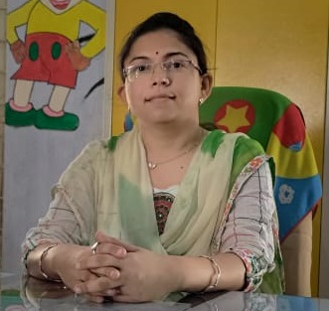

STEM project at Shri Mota Kandagara Group Primary school.

This is to certify that the STEM project was implemented by Sai’s Angel Foundation in our Shri Mota Kandagara Primary School. Under this project Children from Standard 6 to 8 were given various activities in Mathematics, Science and Basic Skills. Children were enthusiastically involved in this activity. Especially in this project, different groups of children were formed and were made to do beautiful fun activities, models and games in which the children themselves prepared various wonderful models of the science subject. The project tried to explain mathematics to the students in a simple way through various activities and games. Basic skills of reading, writing and numeracy were taught to the students in a simple way through various games and creative activities. This benefited students a lot. So the students of our school will benefit greatly from this project in future. We are thankful to the school staff, SMC, Sai’s Angel Foundation and Tata Power for doing this beautiful work.

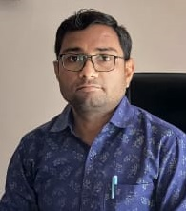Vipulkumar S. Chauhan

Principal, Vandh Pri. School

Mundra –Kachchh.

Regarding feedback on STEM project at Shri Tunda -Vandh Primary School.

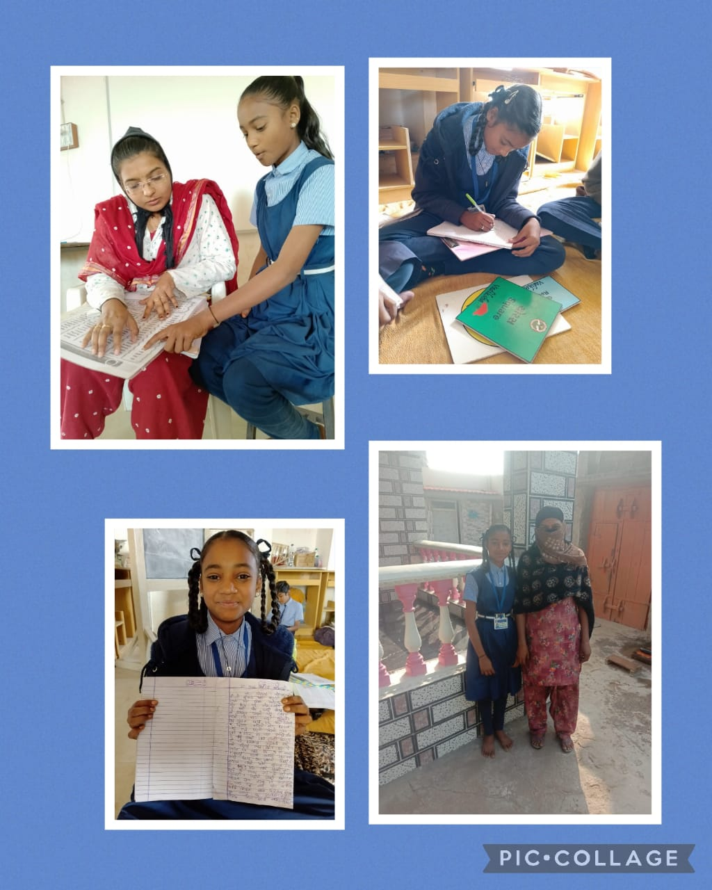This is to certify that the STEM (Science Technology, Engineering, Maths) project implemented by Sai’s Angel Foundation in our Shri Tunda-Vandh Primary School. Under this project Children from standard. 6th to 8th were given various activities in Mathematics, Science and Basic Skills. Children participated actively in various activities. Especially in this project, groups of the children were formed and did wonderful activities, models and games in which they prepared various models of science subject. The project tried to explain mathematics to the students in an interesting way using various TLMs. Basic skills of reading, writing and numeracy were taught to the students in a simple way through various games activities. This benefited the students a lot. We are thankful to the school staff, SMC, including Sai’s Angel Foundation and Tata Power for this support.

**CASE STUDIES:**

Name of Student: Nikhat Jusabhai Vagher

Name of School: Shri Gundyali Primary school

STD: 8th,  ‘C’ Group

Name of Father: Jashubhai Vagher

Name of Mother: Naznin Vagher

Occupation of Mother: Housewife

Occupation of Father: Job of Driver

Nikhat lives with her parents and younger brother. Nikhat’s father is doing job of driver and mother is a housewife. Nikhat was very weak in studies and so after baseline tests of SAF, she become part of ‘C’ group of SAF. During initial 1 month of intervention with Nikhat at school, SAF staff found very less improvement in Nikhat. The reason for her poor progress was her consistent absenteeism in the class. SAF staff visited parents and explained them significance of her attendance in the school. Hence, she started attending school and SAF class regularly.

SAF staff had seen following improvement in Nikhat

* In Maths, she learnt in Numbers – ascending, descending numbers, place value, addition, subtraction and now able to make efforts to do division also.
* In Guajarti, Nikhat could read words, sentences, could write essay and understood comprehension.
* Nikhat started participating in telling and discussing stories, children songs and other games in the class
* Nikhat scored 27%, 18% and 16% in Gujarati, Maths and English respectively in her pre test that increased to 60%, 83% and 84% in her post test. Similarly, in her pre test of reading she has scored almost zero whereas in post test she cleared all her reading ability marks.

SAF teacher had taken views of parents also. Parents were happy that Nikhat regularly attended school and was able to do basics of Gujarati and Maths. Parents stated that ‘teaching through playing’ had helped Nikhat to learn quickly but her handwriting was still a concern. SAF teacher paid attention to this, gave her more writing practice and her handwriting improved too.